
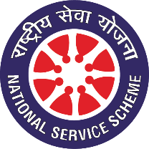
Pune District Education Association’s
Seth Govind Raghunath Sable College of Pharmacy, Saswad, Pune.
National Service Scheme
-------------------------------------------------------------------------------------
Report on Campus Cleanliness Drive
Date: 27th July 2026
Organized by: NSS Unit

On the occasion of the Birth Anniversary of Late Hon. Shri. Ajitdada Pawar Saheb, Former Deputy Chief Minister, Government of Maharashtra, and President, Pune District Education Association (PDEA), Pune, the National Service Scheme (NSS) Unit of college organized a Campus Cleanliness Drive to pay tribute to his vision of social responsibility, discipline, and community service.
The programme commenced with the gathering of NSS volunteers, teaching and non-teaching staff members. Principal Dr. Rajashree Chavan addressed the gathering and highlighted the importance of maintaining cleanliness within the campus and in society. She emphasized the harmful effects of plastic pollution on the environment and encouraged everyone to minimise the use of single-use plastics by adopting eco-friendly alternatives. She also inspired students to actively participate in cleanliness initiatives and contribute towards building a cleaner, greener, and healthier environment.
The cleanliness drive was conducted across the college campus with the objective of promoting cleanliness, environmental awareness, and a sense of civic responsibility among students. NSS volunteers enthusiastically participated in cleaning the campus premises, collecting plastic and other waste materials, and ensuring that the surroundings remained neat, hygienic, and litter-free.
During the activity, volunteers also spread awareness among students and staff about the importance of maintaining a clean environment, proper waste segregation, and reducing the use of single-use plastics. The programme highlighted that cleanliness is not only essential for a healthy campus but also reflects the values of discipline, respect, and environmental stewardship.
The programme concluded with a pledge by all participants to continue practising cleanliness in their daily lives and to contribute actively towards environmental conservation and sustainable development.
.

Mr. Sumit Musale | Dr. Rajashree Chavan

Photo Gallery

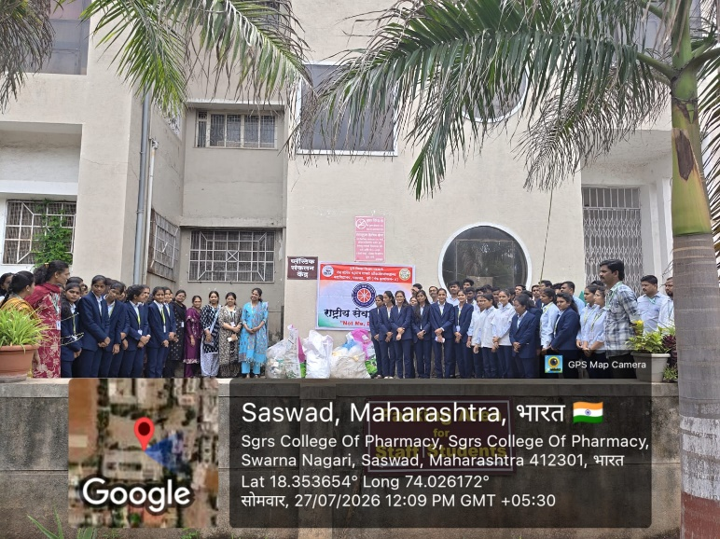 | 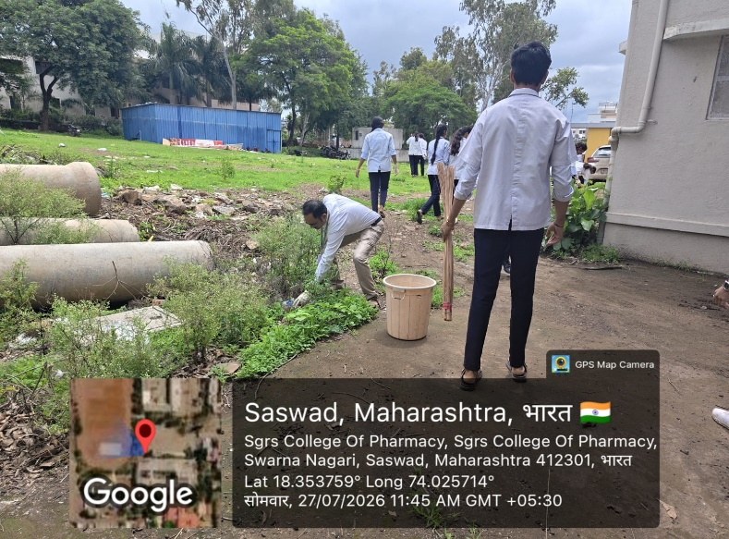
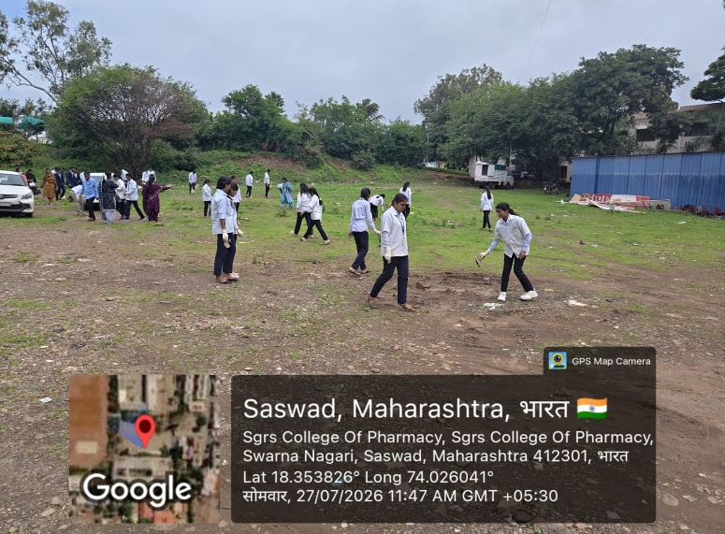 | 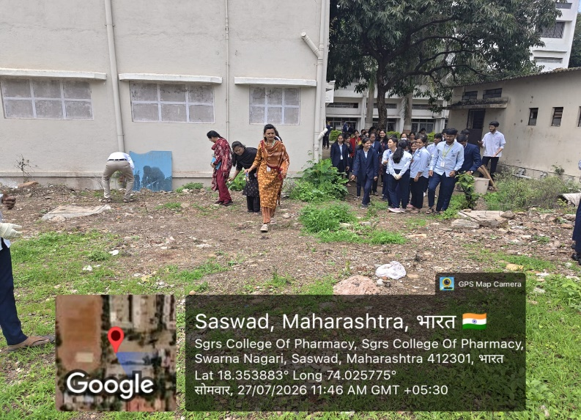

Mr. Sumit Musale | Dr. Rajashree Chavan

