Pune District Education Association’s
Seth Govind Raghunath Sable College of Pharmacy, Saswad
Activity Report
Title of the event: Debate Competition
Date and Day: 23/07/2026, Thursday Time: 11:00 am – 12.30 pm
Venue: Seminar hall
------------------------------------------------------------------------------------------------------------------------------------------Report on Debate Competition
23st July 2026

Pune District Education Association’s Seth Govind Raghunath Sable College of Pharmacy, Saswad organized a Debate Competition on the occasion of the Birth Anniversary of Late Hon. Shri Ajitdada Pawarsaheb on 23th July 2026. The objective of the Debate Competition is to enhance students' communication, critical thinking, and public speaking skills through constructive discussion. It also aims to encourage analytical thinking, confidence, and awareness of contemporary issues by promoting the exchange of diverse viewpoints.
The Debate Competition was open to all D. Pharm., B. Pharm. and M. Pharm. students of the college. Participants expressed their views on the topic "Mobile Phones, Social Media & AI: Pros and Cons" by presenting well-reasoned arguments both in favour of and against the motion. The competition provided an excellent platform for students to enhance their public speaking, critical thinking, analytical, and communication skills while fostering confidence, healthy discussion, and awareness of contemporary issues.
All the faculty, supporting staff members and students participated enthusiastically in the program. The program was attended by total 16 students and 35 staff. Dr. Jayashri Jagtap and Mrs. Deepali Jagtap are evaluated all the participants. After an intense competition, [First Rank- 3rd Year B. Pharm] secured the first prize, followed by [Second Rank- Final Year B. Pharm and Third Rank- 2nd .Year .D. Pharm (Poly)]. The judges praised all teams for their thoughtful arguments and for using debate as a platform to drive change.
The programme was successfully conducted under the guidance of Dr. Rajashree Chavan, Principal. The overall coordination of the event was carried out by Ms. Pooja Petkar, & Ms. Pooja Rokade. The programme was effectively anchored by Ms. Pooja Petkar. The vote of thanks was delivered by Ms. Pooja Rokade. The programme concluded with appreciation for all participants and encouraged students to continue expressing their creativity and contributing positively to society through innovation, leadership, and academic excellence.

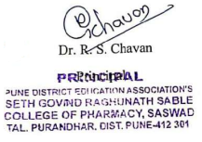
Pune District Education Association’s Seth Govind Raghunath Sable College of Pharmacy, Saswad
Debate Competition 23st July 2026
Photo Gallery
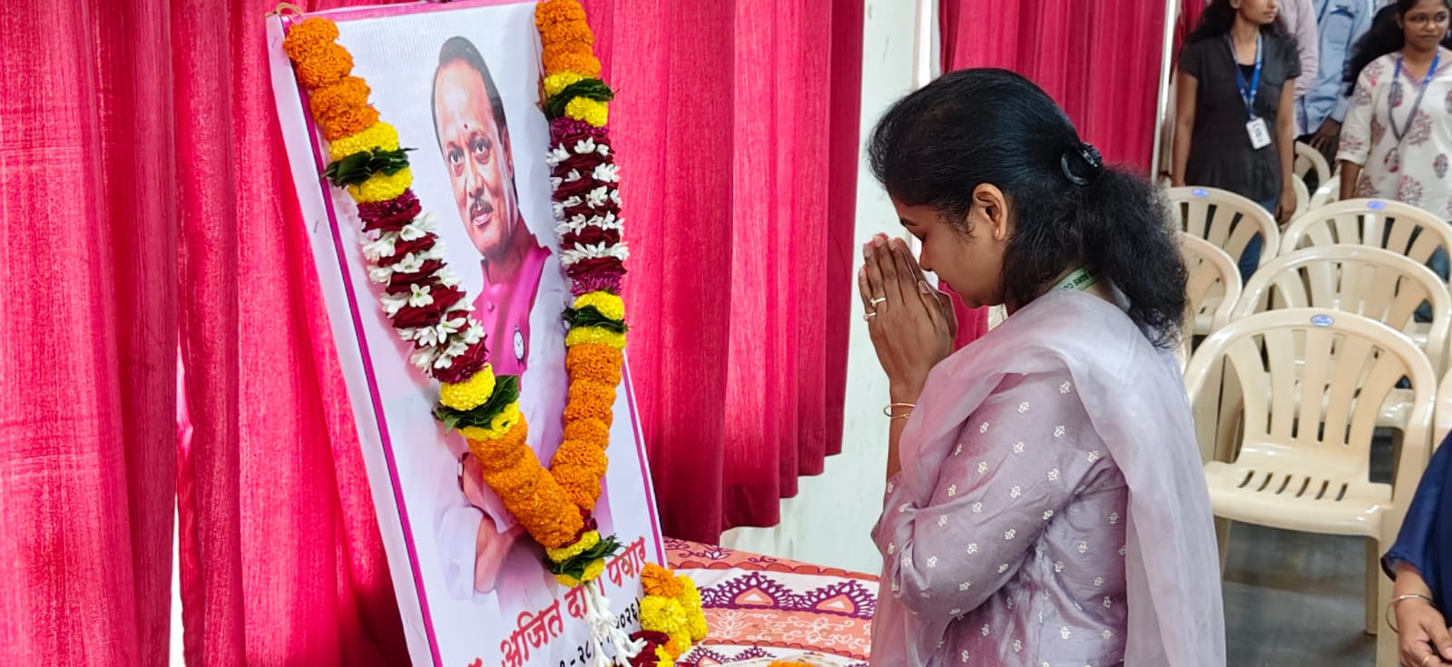
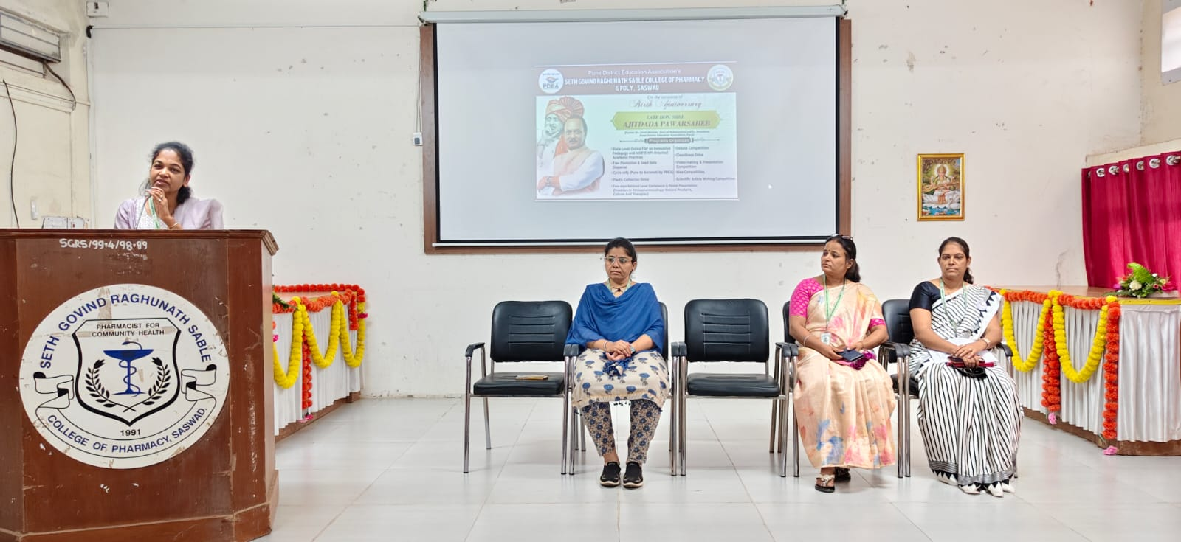
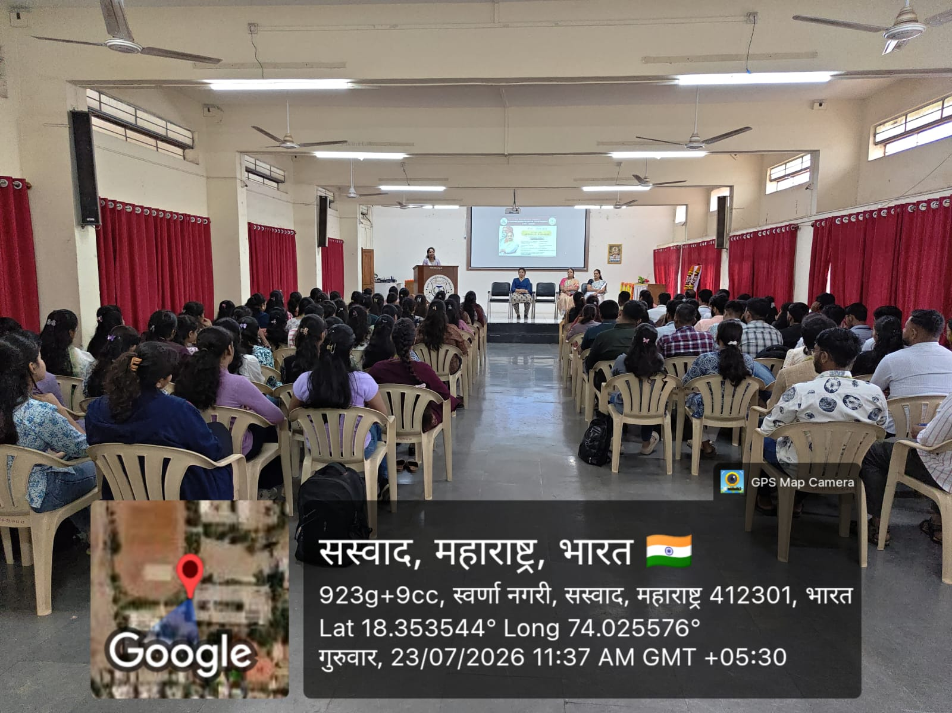

Pune District Education Association’s Seth Govind Raghunath Sable College of Pharmacy, Saswad
Debate Competition 23st July 2026

