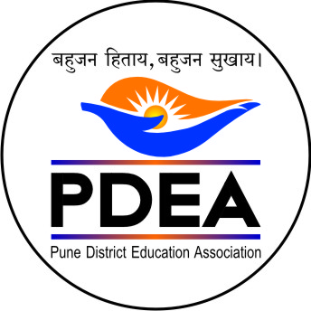
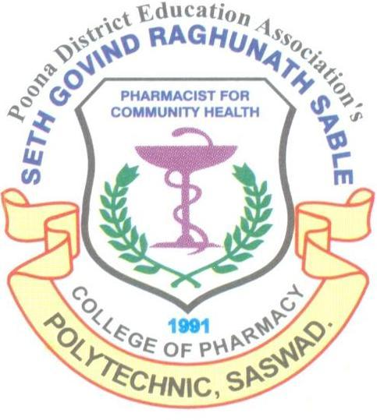
Pune District Education Association’s
Seth Govind Raghunath Sable College of Pharmacy & Polytechnic, Saswad.

Activity Report

One-Day State-Level Online Faculty Development Program (FDP)

"Innovative Pedagogy and MSBTE KPI-Oriented Academic Practices"
Date: Monday, 20th July 2026
Platform: Zoom (Online)
Organized by: PDEA's Seth Govind Raghunath Sable College of Pharmacy & Polytechnic, Saswad
In collaboration with: National Pharmacy Welfare Association (NPWA)
Under NPWA Membership Activities on the occasion of the Birth Anniversary of Late Hon. Ajitdada Pawar, Former President, Pune District Education Association, Pune.

PDEA's Seth Govind Raghunath Sable College of Pharmacy & Polytechnic, Saswad, in collaboration with the National Pharmacy Welfare Association (NPWA), successfully organized a One-Day State-Level Online Faculty Development Program (FDP) on "Innovative Pedagogy and MSBTE KPI-Oriented Academic Practices" through the Zoom platform.
The FDP received an overwhelming response from the pharmacy fraternity, with 263 faculty members registering for the programme. Participants represented Government, Government-aided, and private pharmacy institutions from almost every district of Maharashtra as well as institutions from the border regions of Karnataka, making the programme a truly inter-state academic initiative.

Programme Proceedings:
- The programme commenced with the online joining of participants.
- Mrsr. Vishakha S. Gaikwad, Principal (MSBTE 0231), delivered the welcome address and introduced the objectives of the FDP. She emphasized the importance of innovative teaching methodologies and MSBTE KPI-oriented academic practices in enhancing the quality of pharmacy education.
- Dr. R. S. Chavan, Principal, addressed the gathering and appreciated the collaborative initiative of PDEA and NPWA. She encouraged faculty members to continuously upgrade their professional competencies for achieving excellence in pharmacy education.
- The Keynote Address was delivered by Prof. Pravin Jawale, Executive President, National Pharmacy Welfare Association (NPWA). He highlighted the significance of continuous faculty development, academic excellence, quality enhancement, and the adoption of innovative educational practices.
- Prof. Sagar V. Bhise, FDP Coordinator, introduced the first resource person, Dr. Prashant Aragade, Senior Lecturer, Department of Pharmacy, Government Polytechnic, Jalgaon.
Technical Session-I on "MSBTE KPI-Oriented Academic Practices" was conducted by Dr. Prashant Aragade. The session covered:
  - MSBTE Key Performance Indicators (KPIs)
  - Academic planning and documentation
  - Course file preparation
  - Outcome-Based Education (OBE)
  - Quality assurance practices
  - Continuous improvement strategies
  - Institutional best practices
The session concluded with an interactive question-and-answer session, where participants actively discussed various academic issues and implementation strategies.
Mrs. Deepali Jagtap introduced the second resource person, Dr. Remeth J. Dias, Head of Department (D. Pharm), Government College of Pharmacy, Karad.

Technical Session-II on "Innovative Pedagogy" was delivered by Dr. Remeth J. Dias. The session focused on:
  - Learner-centric teaching methodologies
  - Active learning strategies
  - Innovative classroom practices
  - Technology-enabled teaching
  - Outcome-based learning
  - Innovative assessment techniques
  - Student engagement strategies
The session was highly interactive and concluded with an engaging discussion and question-answer session.
During the open discussion and participants' feedback, faculty members appreciated the relevance and practical utility of both technical sessions. Dr. Vishal Karkhile, Head of Department, Sitabai Thite College of Pharmacy, Shirur, appreciated the excellent organization of the FDP and commended both resource persons for delivering informative, practical, and inspiring sessions.
The vote of thanks was proposed by Mrs. Seema Kenjale, who expressed sincere gratitude to the management of PDEA, National Pharmacy Welfare Association (NPWA), dignitaries, resource persons, participants, and the organizing committee for making the programme a grand success.
The participants were informed about the online feedback process and the issuance of e-certificates.
The programme concluded with the singing of the National Song – "Vande Mataram."

Programme Outcomes:
The FDP successfully achieved the following outcomes:
- Enhanced understanding of MSBTE KPI-Oriented Academic Practices among pharmacy educators.
- Promoted innovative, learner-centric, and outcome-based teaching methodologies.
- Strengthened awareness regarding quality assurance and continuous improvement in pharmacy education.
- Encouraged professional networking among faculty members from Maharashtra and the border regions of Karnataka.
- Motivated educators to implement innovative pedagogical practices for improving teaching-learning effectiveness.
The enthusiastic participation of 263 faculty members and the highly positive feedback received from participants reflected the success and academic relevance of the programme. The FDP served as an effective platform for professional development and reaffirmed the institution's commitment to promoting quality pharmacy education.

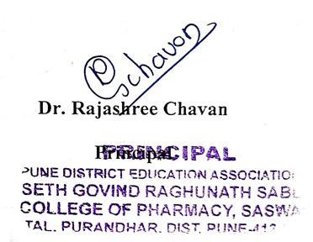

Photo gallery of FDP (20-07-2026)
