
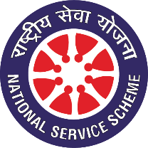
Pune District Education Association’s
Seth Govind Raghunath Sable College of Pharmacy, Saswad, Pune.
National Service Scheme
----------------------------------------------------------------------------------------------
Report on

Tree Plantation and Seed Ball Dispersal Activity
Date: 21st July 2026
Place: Wagh Dongar

The National Service Scheme (NSS) Unit of college organized a Tree Plantation and Seed Ball Dispersal Activity on the occasion of the Birth Anniversary of Late Hon. Shri. Ajitdada Pawar Saheb, Former Deputy Chief Minister, Government of Maharashtra, and President, Pune District Education Association (PDEA), Pune.
The activity was organized with the objective of promoting environmental conservation, enhancing green cover, and creating awareness among students regarding the importance of protecting and preserving nature. During the programme, NSS volunteers planted saplings of various native species and dispersed seed balls in suitable locations to encourage natural afforestation and biodiversity conservation.
The programme was graced by Dr. Rajashree S. Chavan, Principal, who inspired the volunteers through her address and emphasized the importance of environmental sustainability. She encouraged students to actively participate in conservation initiatives and to contribute towards building a greener and healthier future.
The event witnessed enthusiastic participation from NSS volunteers, teaching faculty, and non-teaching staff. Volunteers actively prepared planting sites, planted saplings, dispersed seed balls, watered the plants, and pledged to nurture them in the coming months. The activity reflected the commitment of the NSS Unit towards environmental protection and sustainable development while paying tribute to the visionary leadership and legacy of Late Hon. Shri. Ajitdada Pawar Saheb.
The programme was was successfully coordinated by Mr. Sumit Musale under the guidance of Dr. Rajashree Chavan,

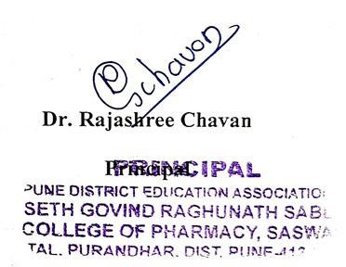

Photo Gallery

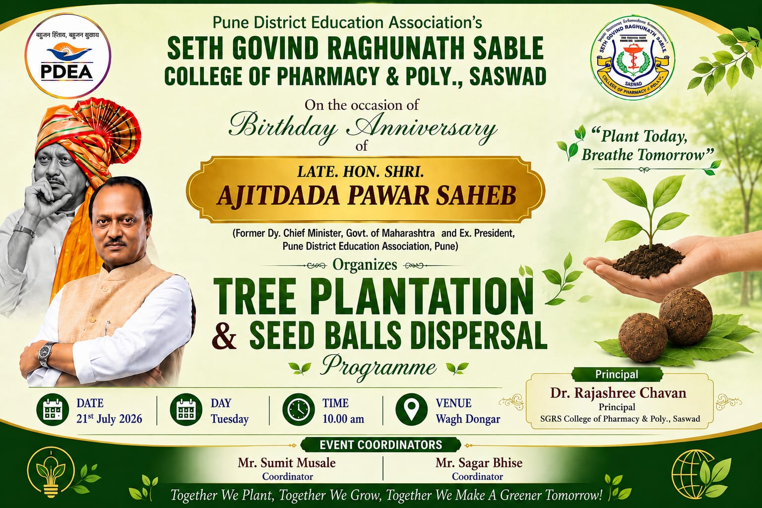 | 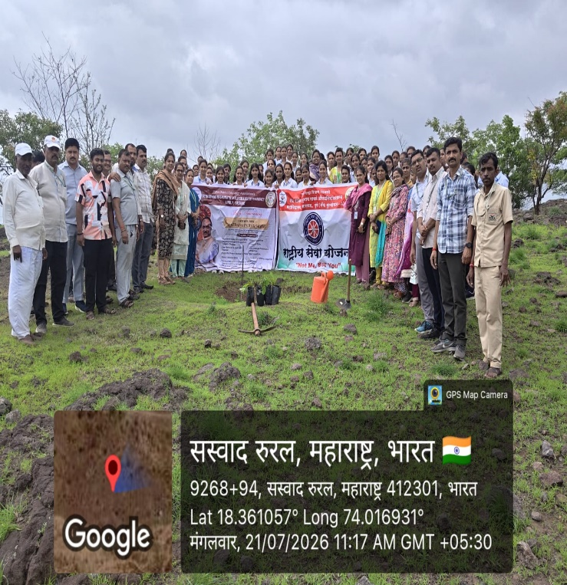
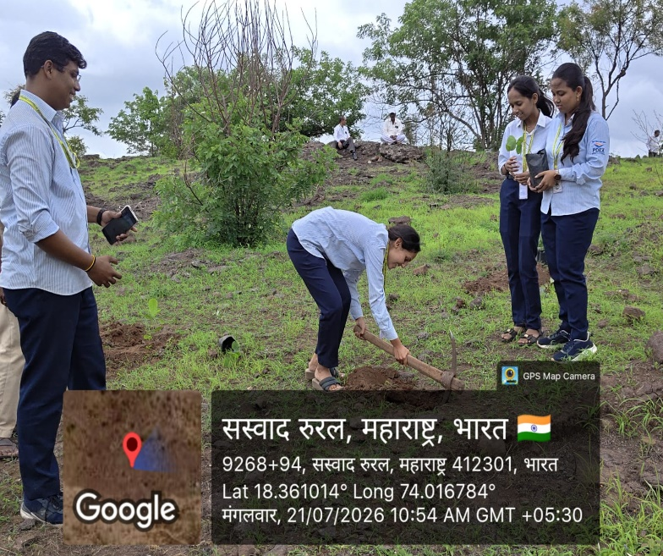 | 